**What is Agile?**

Agile methodology is a project management and software development approach that aims to be more effective.

1. It focuses on delivering smaller pieces of work regularly instead of one big launch.
2. This allows teams to adapt to changes quickly and provide value to customers faster.

**What is the Agile Methodology?**

Agile methodologies are iterative and incremental, which means it’s known for breaking a project into smaller parts and adjusting to changing requirements.

1. They prioritize flexibility, collaboration, and customer satisfaction.
2. Major companies like Facebook, Google, and Amazon use Agile because of its adaptability and customer-focused approach.

**Life cycle of Agile Methodology**

The Agile software development life cycle helps you break down each project you take on into six simple stages:

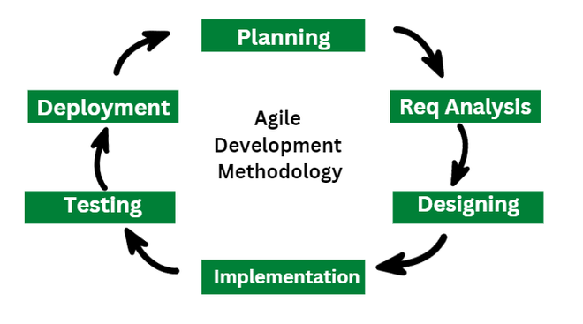

**1. Requirement Gathering**

* In this stage, the project team identifies and documents the needs and expectations of various stakeholders, including clients, users, and subject matter experts.
* It involves defining the project’s scope, objectives, and requirements.
* Establishing a budget and schedule.
* Creating a project plan and allocating resources.

**2. Design**

* Developing a high-level system architecture.
* Creating detailed specifications, which include data structures, algorithms, and interfaces.
* Planning for the software’s user interface.

**3. Development (Coding)**

Writing the actual code for the software. Conducting unit testing to verify the functionality of individual components.

**4. Testing**

This phase involves several types of testing:

1. **Integration Testing:** Ensuring that different components work together.
2. **System Testing:** Testing the entire system.
3. **User Acceptance Testing:** Confirming that the software meets user requirements.
4. **Performance Testing:**Assessing the system’s speed, scalability, and stability.

**5. Deployment**

1. Deploying the software to a production environment.
2. Put the software into the real world where people can use it.
3. Make sure it works smoothly in the real world.
4. Providing training and support for end-users.

**6. Review (Maintenance)**

1. Addressing and resolving any issues that may arise after deployment.
2. Releasing updates and patches to enhance the software and address problems.

## When to use the Agile Methodology?

**Unclear or Changing Requirements**

**Complex Projects**

**Customer Focus**

**Team Skills**

**Collaboration**

## Benefits of Agile Methodology

The advantages of the agile model are as follows:

1. **Immediate Feedback:**It allows immediate feedback, which aids software improvement in the next increment.
2. **Adapts to Changing Requirements:** It is a highly adaptable methodology in which rapidly changing requirements, allowing responsive adjustments.
3. **Face-to-Face Communication:** Agile methodology encourages effective face-to-face communication.
4. **Time-Efficient:**It is well-suited for its time-efficient practices, which help in delivering software quickly and reducing time-to-market.
5. **Frequent Changes:**It effectively manages and accommodates frequent changes in project requirements according to stakeholder convenience.
6. **Customer Satisfaction:** It prioritizes customer satisfaction.
7. **Flexibility and Adaptability:**Agile methodologies are known for their flexibility and adaptability.

## Core Values of Agile Software Development:

The Agile Software Development Methodology Manifesto describe four core values of Agile in software development.

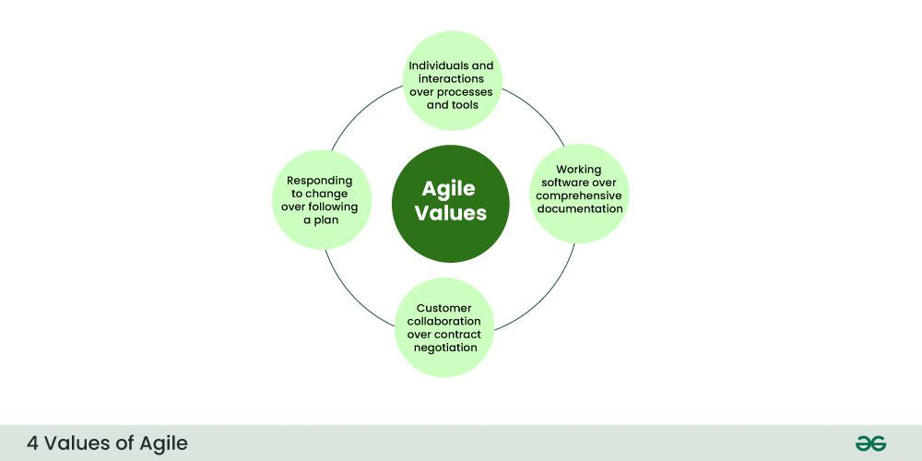

*4 Core Values of Agile Software Development Methodology*

1. Individuals and Interactions over Processes and Tools
2. Working Software over Comprehensive Documentation
3. Customer Collaboration over Contract Negotiation
4. Responding to Change over Following a Plan

## 12 Principles of Agile Software Development Methodology

The Agile Manifesto is based on four values and twelve principles that form the basis, for methodologies.

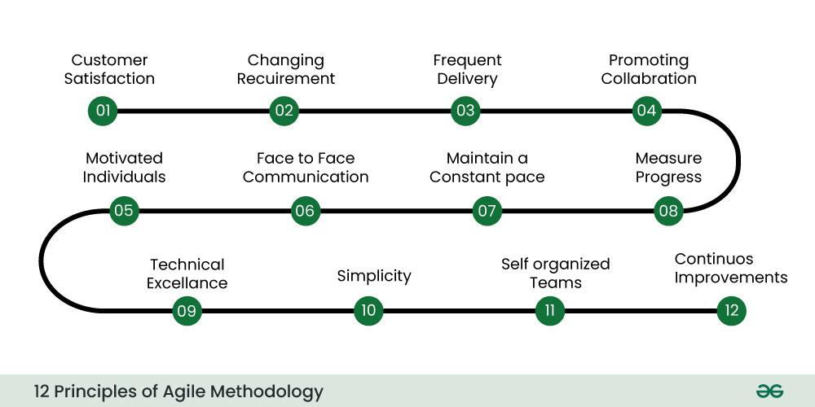

*12 Principles of Agile Software Development Methodology*